Treasure Box!  Use a small, empty box (matchbox size). How many non-living items can you find that fit in your box.  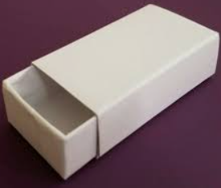 | Treasure Hunt!  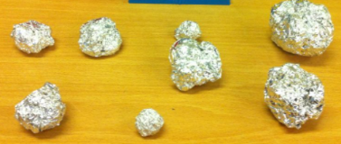  Wrap a pebble/stone in foil or paint in a bright colour. Take it in turns to hide the treasure then get people to find your treasure. You could hide more than one piece of treasure
A hand sized Scavenger Hunt!  Find objects of certain sizes.  - A stick smaller than your hand  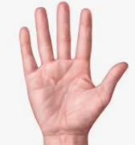  - -A blade of grass longer than your little finger  - A leaf as wide as your hand span  A stone that fits inside your hand. | Treasure Markings  Take rubbings of different surfaces/objects.  You could use foil – press the foil down onto different surfaces and gently rub to get the impression. You could also use paper or clay.  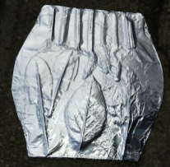

To get yourself off the screen and outside, try these activities. All these activities are all about looking at our environment. Remember when looking at nature always take non-living things from the ground. Trees and plants need their sticks and leaves so please leave them be.

