**Mastering Number at St Paul’s Primary School**

**Principles underpinning Mastering Number at our school:**

* Developing fluency makes more pupils better able to access the maths in the main lesson easier to learn for more pupils.

We do this by making connections between Mastering Number sessions and main lessons.

* Developing our children’s mindset to look for mathematical relationships will aid development and support connections

We do this by drawing pupils’ attention to the relationships so that they can connect with prior learning.

* Building confidence will enable more pupils to make progress

We do this by focussing on enabling all pupils to really understand a small step in learning.

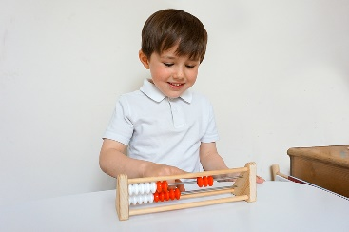

At St Paul’s Primary School, we are actively participating in the NCETM Mastering Number Work Group.

**Over time through our Mastering Number sessions, our pupils will:**

* Develop fluency in calculation and a flexibility with number that exemplifies good number sense.
* Be able to clearly communicate their mathematical ideas.
* Make good progress towards the Early Learning Goals and Year Group Expectations
* Demonstrate a willingness to ‘have a go’

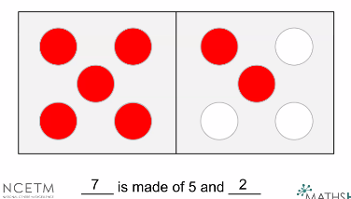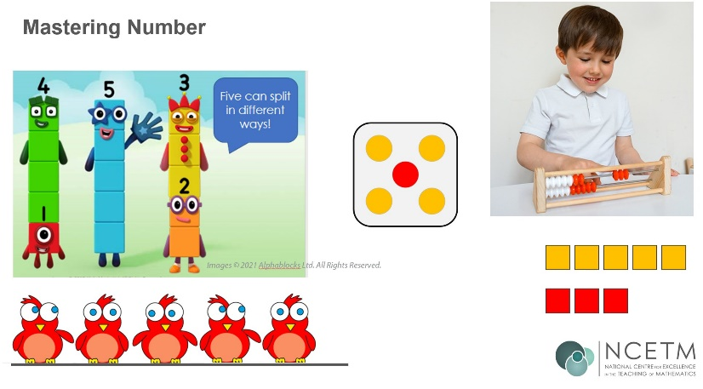

**What you will see in some of our Mastering Number sessions**

* Activities, which are accessible and enable all children to become more confident and competent and are carefully linked to the content of the session.
* They are being supported to acquire key facts and skills they can use more efficiently, which they will use in their maths lessons. These skills will be referred to and modelled in our maths lessons.
* Quick finishers will work on related / connected facts rather than challenge. This does not mean that our children are not challenged! They are focused on the key learning.

**FEATURES OF OUR MASTERING NUMBER SESSIONS**

Our Mastering Number sessions

* are inclusive with all children securing the same learning point in an interactive and engaging manner.
* enable all children to develop number sense and secure core knowledge. This is similar to supporting pupils with phonics knowledge!
* are about accessible learning which enables all children to have a firm understanding.

For all of our pupils to develop depth in understanding we want all of our children to:

* become mathematically observant
* look for relationships
* explain their thinking

Don’t count.

Say the amount.

**Our Mastering Number sessions include:**

* A daily session of 10 to 15 minutes in addition to their daily maths lesson 4 times a week to pupils in YR, Y1 and Y2
* We draw pupils’ attention to the right part – important in terms of structure.

This enables us to draw attention and focus on the key learning step for the session.

* We scaffold understanding by using different manipulatives to expose the same structures.

This enables pupils to develop a more secure understanding of core mathematical structures. Seeing the same concept using a different manipulative often leads to pupils making their own connections thus deepening understanding.

* Conceptual variation - transfer the same mathematics

When our pupils transfer their learning in a well thought out different context, they become confident and make connections in learning.

* Linking the action and the thought – manipulatives secure understanding but are then visualised.